Contents

2.1 Planning project management techniques 1

2.2 Applying appropriate project management techniques 1

Gantt Charts 1

SCRUM Methodology 2

Product Back Catalogue 2

Sprints 2

Kanban - Trello 2

2.3 Using a range of tools & techniques in a recommended way 2

Back Catalogue 2

Gantt Charts 2

Kanban 2

Stand-up meetings 2

2.4 Use & apply industry standard testing regimes 3

Implement techniques 3

Testing 3

Manual tests 3

V model 3

validation 3

2.5 Completing development tasks in a timely matter 3

Unit 33-2.1

# 2.1 Planning project management techniques

When planning a project, the manager would assemble a team based on skillsets, the manager would decide which tools are appropriate for the individual product.

Y brainstorming their team for ideas and experiences, building a Gantt chart, and choosing a development method, to help the team initiate a successful procedure.

# 2.2 Applying appropriate project management techniques

## Gantt Charts

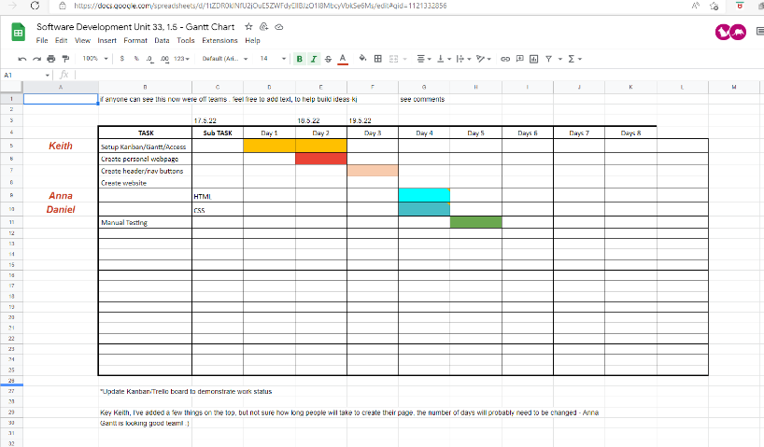A good starting point when planning a project is to build a Gantt chart, this is a visual measure of the assumed procedures and an ongoing progress measurement, members cab access through sharing files and can see where the project is developing, and members can discuss actions needed to be taken.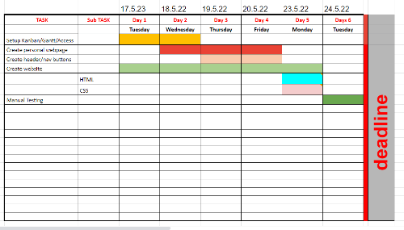

Figure 1 early stages of a Gantt chart

Figure 2 final edition of Gantt chart

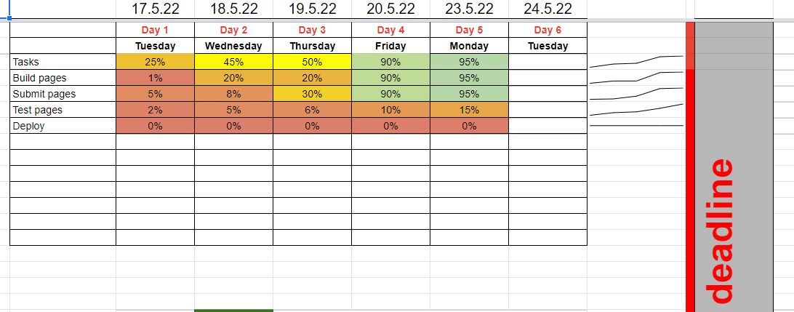

Figure 3 Gantt Process chart

## SCRUM Methodology[1]

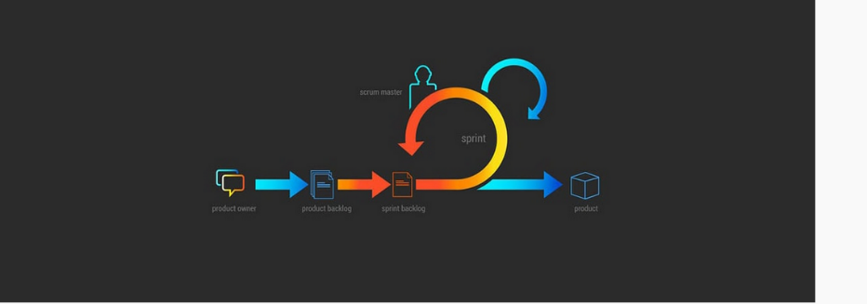Scrum addresses the complexity of monitoring a project, making it easier to understand and transparent. Allows the team to inspect and adapt parts of the project as the work progresses.

Figure SCRUM diagram example

By applying an agile approach, the process is divided into incremental sections known as Sprints, these are time related and can be adapted to suit changing conditions and wants and needs of the product owner.

## Product Back Catalogue

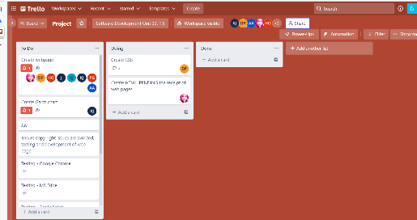Feature the team need to adapt the procedure to ensure the end product is competitive or meets market expectations,

Figure 5 a Trello project combining agile/ Scrum methodology

working with the product owner to ensure the product is of the latest and effective requirement.

## Sprints[2]

Agile scrum techniques, members work with iterations or short cycles, that are time managed by the Scrum master. Team members can review the product backlog and prioritise where necessary.

## Kanban – Trello

Development methodologies, that combine agile to plan and monitor a project. The aim is to boost quality and productivity, by using a board [with sections] to emphasise different elements of the procedure. Using 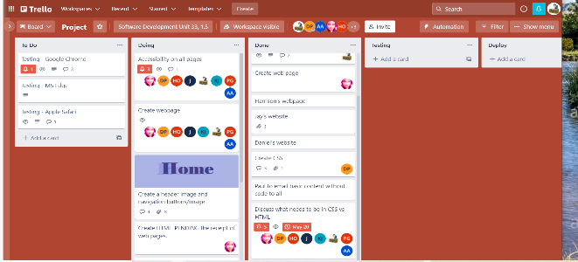

Figure 6 ongoing Trello- used by unit33-1.5

visuals to highlight ongoing progress in planning and executing the procedure.

# 2.3 Using a range of tools & techniques in a recommended way

## Back logs[3]

Helps the team to estimate, refine and prioritise, an ongoing project, that meets with the product owner’s expectations.

The backlog highlights items that need attention and must be addressed for a successful project conclusion.

## Gantt Charts[4]

A project management tool assisting with the planning and scheduling of projects, it can also be used as a means of measuring progress ad can be used to help plan future projects by comparing individual projects.

A visual display of the entire project, including timelines and deadlines, relationships between different elements and project phases.

## Kanban[5]

A popular workflow methodology for defining, managing and improving ongoing projects, helps visualise work issue’s improve efficiency and deliver better products. Using a board as the platform, includes different elements of a procedure, which team members can identify and react to.

## Stand-up meetings[6]

Like sports team huddle where the captain inspires his players with support and directives, a Scrum stand-up meeting represents a similar idea.

As members of a team go about their daily tasks, the scrum methodology, is for teams to have quick meets to discuss any issue’s that may have arisen, thus keeping the project up to date, any new decisions or alterations would be declared on the Trello board for all members to read at their workstations.

“due to the bootcamp being online, the class when working collaborative, need to use an online collaborative tool”, such as Teams od Zoom.

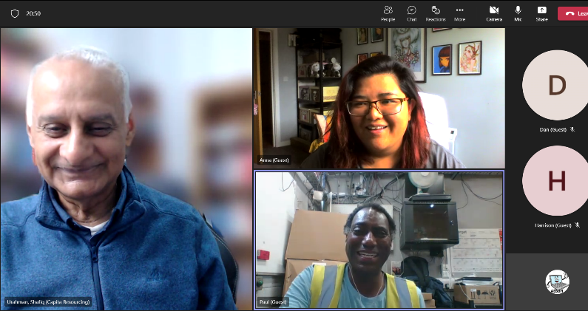

Figure 7 teams meeting in progress

# 2.4 Use & apply industry standard testing regimes

Testing is the process of checking your web pages, to identify any bugs or mistakes prior to deploying to the internet, ensuring that the readers experience is how the developer intended.[7]

## Implement techniques

There are a number techniques for testing;

Figure 8 unit33-1.5 by Anna

* + Build your own test page as the developer to ensure the end product performs as you intended.
* Professional testing
  + Employ a professional website
* ion[8]
  + Completed by developers check the page meets its functions according to code rules
* Validation
  + Completed by testers checking the overall project
* V- Model[9]
  + Uses a testing parallel for each phase of the testing process, to ensure that the product is both Vitrificated and validated, so the end product is code effective, and the page performs as expected. 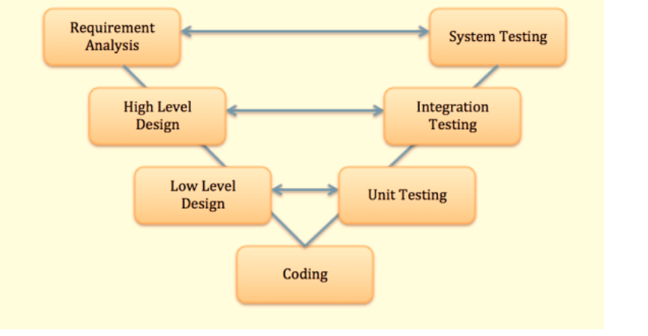

Figure typical V model



# 2.5 Completing development tasks in a timely matter

I would;

* Identify all relevant tasks
* Develop a plan of action (written)-with deadline
* Organise all the necessary hardware and software
* Compose a Gantt chart
* Decide on the budget
* Compose web test page
* Run test
* Deploy

Attain deadline.

1. https://www.atlassian.com/agile/scrum/standups
2. [Sprints | Atlassian](https://www.atlassian.com/agile/scrum/sprints)
3. https://www.perforce.com/resources/hns/agile-product-backlog-basics
4. https://www.apm.org.uk/resources/find-a-resource/gantt-chart/
5. [What Is Kanban? Explained in 10 Minutes | Kanbanize](https://kanbanize.com/kanban-resources/getting-started/what-is-kanban)
6. https://www.atlassian.com/agile/scrum/standups
7. https://www.tutorialspoint.com/software_testing/software_testing_quick_guide.htm
8. https://www.tutorialspoint.com/differences-between-verification-and-validation
9. https://www.guru99.com/v-model-software-testing.html